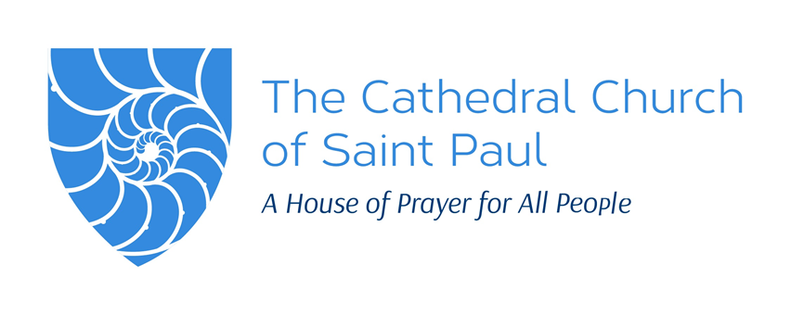

138 Tremont Street, Boston, MA 02111 ▪ 617-482-5800 ▪ cathedral@diomass.org ▪ www.stpaulboston.org

THE HOLY EUCHARIST

Seventh Sunday of Easter ▪ May 12, 2024

WELCOME, ALL!

*Holy Spirit #1 by Colleen Shay*

If this is your first Sunday worshipping with the Cathedral we welcome you and invite you to review our congregational covenant below, which sets out our vision and core commitments.

If you are joining from home, feel free to type into the chat anything for which you would like to have us include during the Prayers of the People.

**\*\*\*\*\*\***

**SUNDAY CONGREGATION COVENANT**

**Created September 2018**

We embrace Christ’s call to respect the dignity of each person, knowing ourselves as equally beautiful and equally in need of God’s grace. When in doubt, we will choose love, rejecting the individualism and violent competitiveness that are rampant in our world.

On Sunday mornings, our shared intention is to worship God. We seek to be transformed by Jesus, who is present in the Word, the sacraments, and each person here, so that we may be the face of Christ to one another and in the world. This calling is precious, and we know it will be costly. While held within the beauty and order of Anglican liturgy, we open ourselves to being divested of prejudices, assumptions, and rigidity.

To help one another walk to freedom in Christ, we will:

• welcome new people joyously,

• allow ordained and lay leaders to focus on the ministry to the whole congregation to which Jesus calls them, holding individual requests and church ‘business’ until after the service,

• incorporate a variety of voices and perspectives into our worship life, through welcoming preachers and presiders from an array of genders, cultures, and social locations; encouraging and training new members to participate in liturgical ministries; and making space in our prayers for individual petitions,

• train and designate members of the congregation to respond to those in distress or particular need during worship, and to take the lead in any situations where safety is uncertain,

• while celebrating that some people have particular, holy callings to help others in hardship, on Sunday mornings we will refer those in financial need to cathedral staff and/or help them brainstorm ways to find what they need, rather than giving out cash,

• pause twice a year to reflect on our experience living into this covenant and adjust our practices if needed, acknowledge and work through conflict, and rejoice in what Christ is doing in our midst,

•strive to be good listeners and grow as a spiritual community through mutual prayer.

As a cathedral congregation, we strive to embody the justice and openness to brave change to which our diocese is committed through its mission strategy.

**La Iglesia Catedral de San Pablo, Boston**

**El Convenio para la congregación del domingo**

**Traducido y actualizado el 7 de julio de 2022**

Celebramos el llamado de Cristo a respetar la dignidad de cada persona, reconociéndonos como recipientes mutuales y agradecidos de la gracia inmerecida de Dios. En caso de duda, elegiremos el amor, rechazando el individualismo y egoísmo perverso que campan a sus anchas en nuestro mundo. Nos esforzamos por convertirnos en una comunidad antirracista.

Los domingos por la mañana, nuestra intención compartida es adorar a Dios. Buscamos ser transformados por Jesús, quien está presente en la Palabra, los sacramentos y cada persona aquí, para que podamos ser el rostro de Cristo los unos para los otros y en el mundo. Este llamamiento es precioso y sabemos que será costoso. Mientras nos mantengamos dentro de la belleza y el orden de la liturgia anglicana, nos abrimos a ser despojados de prejuicios, suposiciones y rigidez.

Para ayudarnos unos a otros a caminar hacia la libertad en Cristo, haremos lo siguiente:

* dar la bienvenida al extranjero con alegría,
* disponernos para escuchar bien a los demás y crecer como comunidad espiritual a través de la oración mutua.
* permitir que los líderes ordenados y laicos se centren en el ministerio de toda la congregación a la que Jesús los llama, manteniendo las solicitudes individuales y los "asuntos" de la iglesia hasta después del servicio,
* incluir una variedad de voces y perspectivas en nuestra vida de adoración, dando la bienvenida a predicadores y presidentes de una variedad de géneros, culturas y lugares sociales; alentar y capacitar a los nuevos miembros para que participen en los ministerios litúrgicos; y haciendo espacio en nuestras oraciones para peticiones individuales,
* entrenar e identificar miembros de la congregación para responder a las personas afligidas o aquellos que tengan una necesidad particular, y para tomar la iniciativa en cualquier situación donde haya una falta de seguridad.
* mientras celebramos que algunas personas tienen dones sagrados y únicos para ayudar a otros en dificultades, los domingos por la mañana referiremos a aquellos con necesidades financieras al equipo de la catedral en lugar de dar dinero en efectivo,
* Reunirnos dos veces al año para reflexionar sobre nuestra experiencia viviendo en este pacto y ajustar nuestras prácticas si es necesario, reconocer y trabajar a través del conflicto, y regocijarnos en lo que Cristo está haciendo entre nosotros,

Como congregación de la catedral, procuraremos encarnar la justicia y manifestar un cambio valiente con el que nuestra diócesis está comprometida por su estrategia de misión.

PRELUDE   
“I know that my Redeemer Liveth” by G. F. Handel (1685-1756)

**THE GATHERING**

OPENING HYMN ***All sing.***

# “Crown him with many crowns” The Hymnal 1982, #494

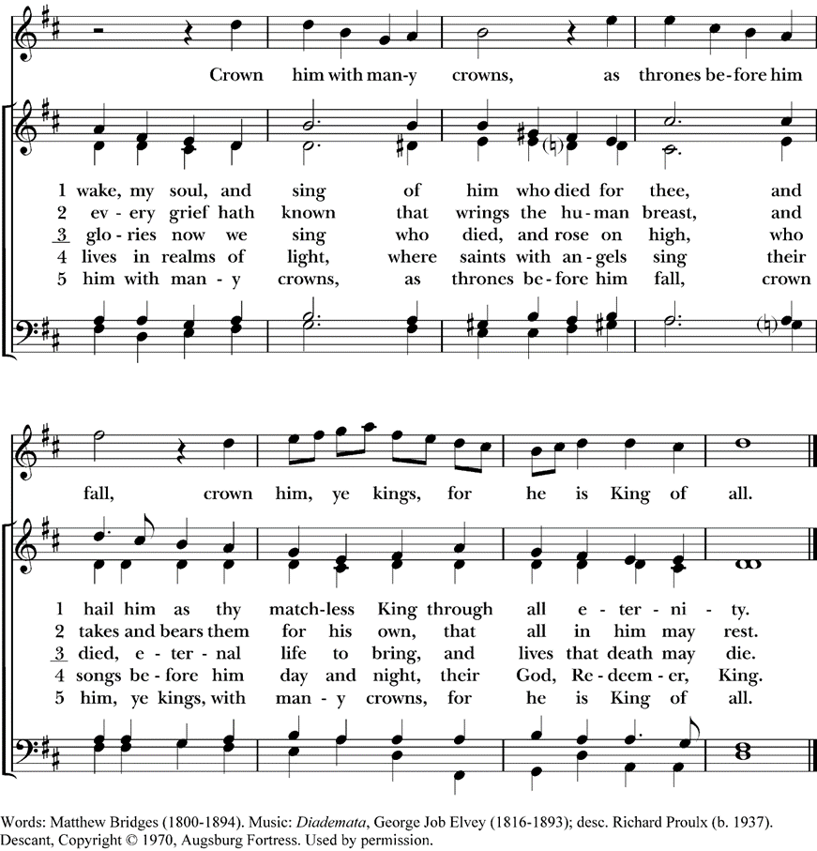

WELCOME Martha Gardner

Alleluia! Christ is risen.

**Christ is risen indeed. Alleluia!**

COLLECT

Let us pray.

O God, Creator of glory, you have exalted your only Son Jesus Christ with great triumph to your kingdom in heaven: Do not leave us comfortless, but send us your Holy Spirit to strengthen us, and exalt us to that place where our Savior Christ has gone before; who lives and reigns with you and the Holy Spirit, one God, in glory everlasting. **Amen.**

ALLELUIA  ***All sing.***

“Alleluia and verses” WLP, #848

Their delight is in the law of the Lord, and on this law they meditate day and night.

### *Music continues on the next page.*

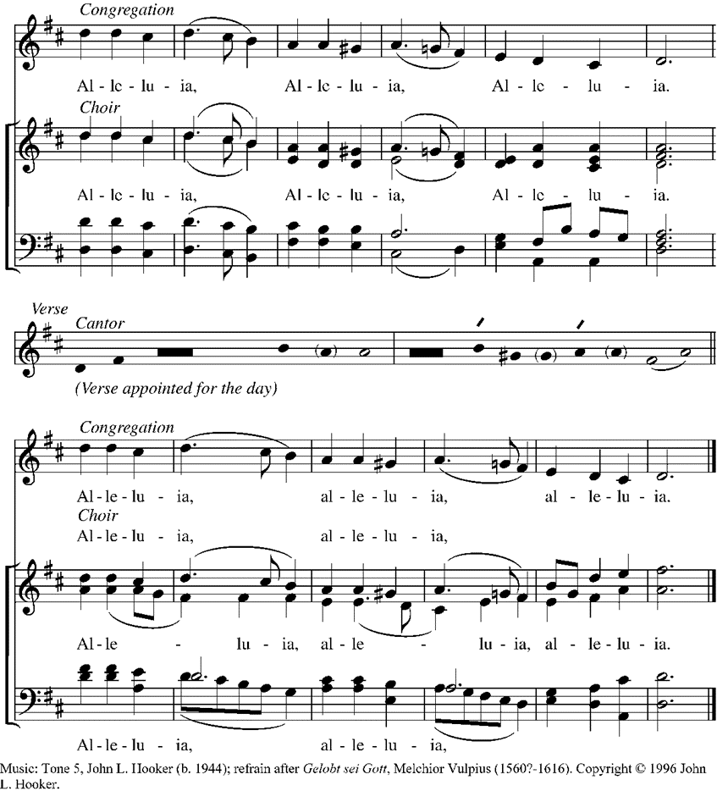

**THE WORD OF GOD**

|  |  |
| --- | --- |
| FIRST READING  Acts 1:15-17, 21-26  In those days Peter stood up among the believers (together the crowd numbered about one hundred twenty persons) and said, "Friends, the scripture had to be fulfilled, which the Holy Spirit through David foretold concerning Judas, who became a guide for those who arrested Jesus-- for he was numbered among us and was allotted his share in this ministry. So one of the men who have accompanied us during all the time that the Lord Jesus went in and out among us, beginning from the baptism of John until the day when he was taken up from us-- one of these must become a witness with us to his resurrection." So they proposed two, Joseph called Barsabbas, who was also known as Justus, and Matthias. Then they prayed and said, "Lord, you know everyone's heart. Show us which one of these two you have chosen to take the place in this ministry and apostleship from which Judas turned aside to go to his own place." And they cast lots for them, and the lot fell on Matthias; and he was added to the eleven apostles.  Hear what the Spirit is saying to God’s people.  **Thanks be to God**. | PRIMERA LECTURAHechos 1:15-17, 21-26  Por aquellos días Pedro se dirigió a los hermanos reunidos, que eran como ciento veinte personas, y les dijo: «Hermanos, tenía que cumplirse lo que el Espíritu Santo, por medio de David, ya había dicho en la Escritura acerca de Judas, el que sirvió de guía a los que arrestaron a Jesús. Pues Judas era uno de los nuestros, y tenía parte en nuestro trabajo. […]  »Tenemos aquí hombres que nos han acompañado todo el tiempo que el Señor Jesús estuvo entre nosotros, desde que fue bautizado por Juan hasta que subió al cielo. Es necesario, pues, que uno de ellos sea agregado a nosotros, para que junto con nosotros dé testimonio de que Jesús resucitó.»  Entonces propusieron a dos: a José, llamado Barsabás, y llamado también Justo, y a Matías. Y oraron así: «Señor, tú que conoces los corazones de todos, muéstranos cuál de estos dos has escogido para que tome a su cargo el servicio de apóstol que Judas perdió por su pecado, cuando se fue al lugar que le correspondía.»  Lo echaron a la suerte, y ésta favoreció a Matías, quien desde aquel momento quedó agregado a los once apóstoles.  Escuchen lo que el Espíritu dice al pueblo de Dios.  **Demos gracias a Dios.** |

PSALM 1

*The cantor will sing the odd verses and the congregation will sing the even verses.*

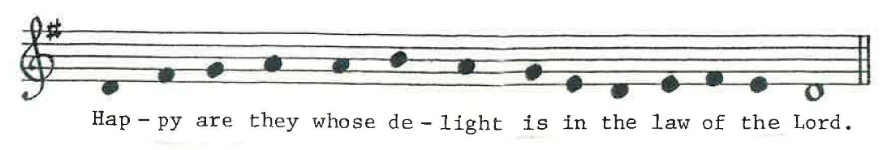

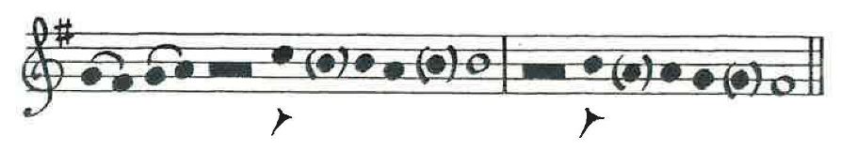

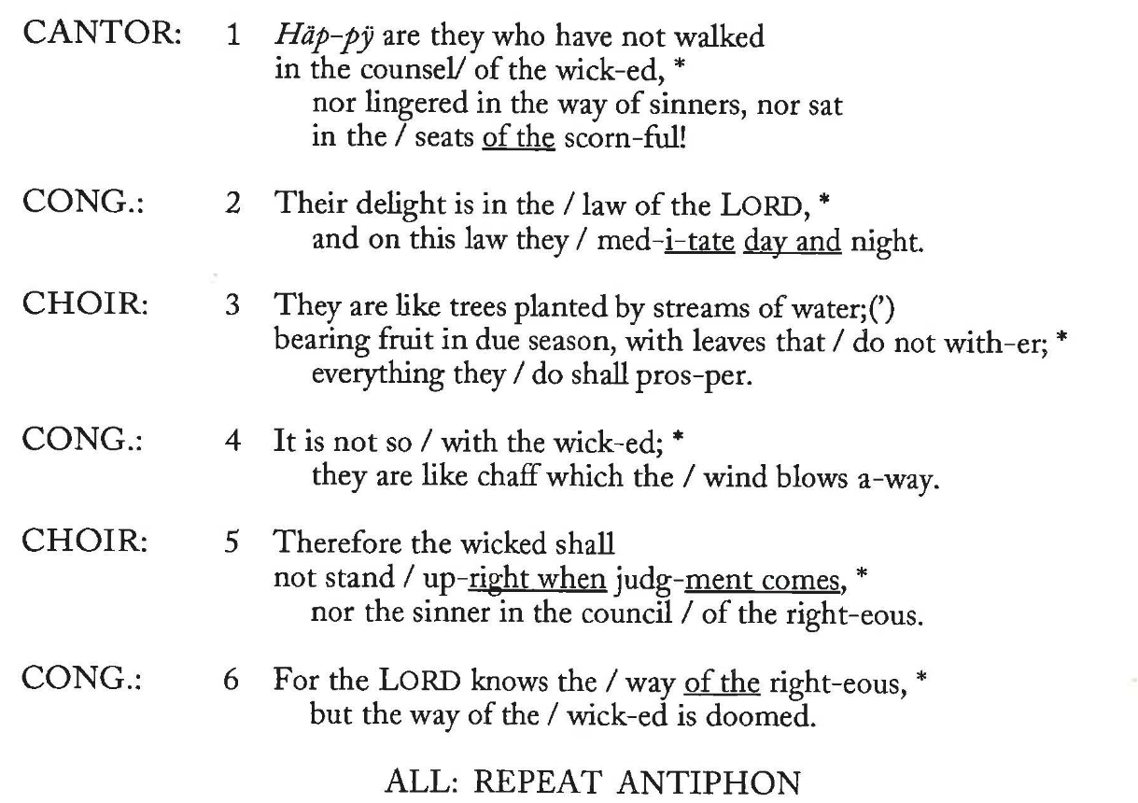

|  |  |
| --- | --- |
| SECOND READING 1 John 5:9-13 If we receive human testimony, the testimony of God is greater; for this is the testimony of God that he has testified to his Son. Those who believe in the Son of God have the testimony in their hearts. Those who do not believe in God have made him a liar by not believing in the testimony that God has given concerning his Son. And this is the testimony: God gave us eternal life, and this life is in his Son. Whoever has the Son has life; whoever does not have the Son of God does not have life.  I write these things to you who believe in the name  of the Son of God, so that you may know that you have eternal life.  Hear what the Spirit is saying to God’s people.  **Thanks be to God**. | SEGUNDA LECTURA  1 Juan 5:9-13 Aceptamos el testimonio de los hombres, pero el testimonio de Dios es de mucho más valor, porque consiste en el testimonio que Dios ha dado acerca de su Hijo. El que cree en el Hijo de Dios, lleva este testimonio en su propio corazón; el que no cree en Dios, lo hace aparecer como mentiroso, porque no cree en el testimonio que Dios ha dado acerca de su Hijo. Este testimonio es que Dios nos ha dado vida eterna, y que esta vida está en su Hijo. El que tiene al Hijo de Dios, tiene también esta vida; pero el que no tiene al Hijo de Dios, no la tiene.  Les escribo esto a ustedes que creen en el Hijo de Dios, para que sepan que tienen vida eterna.  Escuchen lo que el Espíritu dice al pueblo de Dios.  **Demos gracias a Dios.** |

GOSPEL ACCLAMATION ***All sing.***

“The head that once was crowned with thorns” The Hymnal 1982 #483

|  |  |
| --- | --- |
| THE GOSPEL  John 17:6-19  The Holy Gospel of our Savior Jesus Christ according to John.  **Glory to you, O Christ!**  Jesus prayed for his disciples, “I have made your name known to those whom you gave me from the world. They were yours, and you gave them to me, and they have kept your word. Now they know that everything you have given me is from you; for the words that you gave to me I have given to them, and they have received them and know in truth that I came from you; and they have believed that you sent me. I am asking on their behalf; I am not asking on behalf of the world, but on behalf of those whom you gave me, because they are yours. All mine are yours, and yours are mine; and I have been glorified in them. And now I am no longer in the world, but they are in the world, and I am coming to you. Holy Father, protect them in your name that you have given me, so that they may be one, as we are one. While I was with them, I protected them in your name that you have given me. I guarded them, and not one of them was lost except the one destined to be lost, so that the scripture might be fulfilled. But now I am coming to you, and I speak these things in the world so that they may have my joy made complete in themselves. I have given them your word, and the world has hated them because they do not belong to the world, just as I do not belong to the world. I am not asking you to take them out of the world, but I ask you to protect them from the evil one. They do not belong to the world, just as I do not belong to the world. Sanctify them in the truth; your word is truth. As you have sent me into the world, so I have sent them into the world. And for their sakes I sanctify myself, so that they also may be sanctified in truth.”  The Gospel of Christ.  **Praise to you, Christ**. | EL EVANGELIO  John 17:6-19  Santo Evangelio de Nuestro Señor Jesucristo según Juan.  **¡Gloria a ti, Cristo Señor!**  Jesús oró por sus discípulos diciendo: «A los que escogiste del mundo para dármelos, les he hecho saber quién eres. Eran tuyos, y tú me los diste, y han hecho caso de tu palabra. Ahora saben que todo lo que me diste viene de ti; pues les he dado el mensaje que me diste, y ellos lo han aceptado. Se han dado cuenta de que en verdad he venido de ti, y han creído que tú me enviaste.  »Yo te ruego por ellos; no ruego por los que son del mundo, sino por los que me diste, porque son tuyos. Todo lo que es mío es tuyo, y lo que es tuyo es mío; y mi gloria se hace visible en ellos.  »Yo no voy a seguir en el mundo, pero ellos sí van a seguir en el mundo, mientras que yo me voy para estar contigo. Padre santo, cuídalos con el poder de tu nombre, el nombre que me has dado, para que estén completamente unidos, como tú y yo. Cuando yo estaba con ellos en este mundo, los cuidaba y los protegía con el poder de tu nombre, el nombre que me has dado. Y ninguno de ellos se perdió, sino aquel que ya estaba perdido, para que se cumpliera lo que dice la Escritura.  »Ahora voy a donde tú estás; pero digo estas cosas mientras estoy en el mundo, para que ellos se llenen de la misma perfecta alegría que yo tengo. Yo les he comunicado tu palabra, pero el mundo los odia porque ellos no son del mundo, como tampoco yo soy del mundo. No te pido que los saques del mundo, sino que los protejas del mal. Así como yo no soy del mundo, ellos tampoco son del mundo. Conságralos a ti mismo por medio de la verdad; tu palabra es la verdad. Como me enviaste a mí entre los que son del mundo, también yo los envío a ellos entre los que son del mundo. Y por causa de ellos me consagro a mí mismo, para que también ellos sean consagrados por medio de la verdad.»  El Evangelio del Cristo.  **Te alabamos, Cristo.** |

SERMON – Sean Griffin

NICENE CREED *Said by all, standing.*

**We believe in one God, the Father, the Almighty,**

**maker of heaven and earth,**

**of all that is, seen and unseen.**

**We believe in one Lord, Jesus Christ,**

**the only Son of God,**

**eternally begotten of the Father,**

**God from God, Light from Light, true God from true God,**

**begotten, not made, of one Being with the Father;**

**through him all things were made.**

**For us and for our salvation he came down from heaven,**

**was incarnate of the Holy Spirit and the Virgin Mary**

**and became truly human.**

**For our sake he was crucified under Pontius Pilate;**

**he suffered death and was buried.**

**On the third day he rose again in accordance with the Scriptures;**

**he ascended into heaven and is seated at the right hand of the Father.**

**He will come again in glory to judge the living and the dead,**

**and his kingdom will have no end.**

**We believe in the Holy Spirit, the Lord, the giver of life,**

**who proceeds from the Father and the Son,**

**who with the Father and the Son is worshipped and glorified,**

**who has spoken through the prophets.**

**We believe in one holy catholic and apostolic Church.**

**We acknowledge one baptism for the forgiveness of sins.**

**We look for the resurrection of the dead, and the life of the world to come. Amen.**

PRAYERS OF THE PEOPLE

On this the day the Holy One has made, let us rejoice and be glad as we pray to the God who raised Jesus from the dead.

For the people of God, brought through saving waters to a land of promise:

**May we joyfully proclaim, with our lips and our lives,**

**the good news of Christ’s victory over sin and death.**

For all the peoples of earth during this festival of Christ’s resurrection:

**May the gloom of malice and evil yield to a springtime of sincerity and truth.**

For those oppressed by evil, devastated by warfare, or on the road seeking refuge:

**May freedom and safety be theirs and wars cease to plague the people.**

For our partnership in mission in this diocese and Christ's church:

**May we walk together always with Christ in newness of life.**

For those who are sick, homebound, or alone:

**May the risen Christ visit them with healing power and new hope.**

For this holy Earth and our vocation as stewards of it:

**May our care for creation bear witness here to the risen Christ.**

For those who have died and whose lives are hidden with Christ in God, and for those we hold in our hearts:

**May they live forever with Christ in the glory of the resurrection.**

*The intercessor adds specific thanksgivings, prayers, and supplications of the congregation.*

God of life, you sent your Son into the world that we might live through him. May we abide in his risen life, so that we may bear the fruit of love for one another and know the fullness of joy. **Amen.**

THE PEACE

The peace of Christ be always with you.

**And also with you**.

*The People greet one another with a sign of God’s peace.*

ANNOUNCEMENTS

**THE HOLY COMMUNION**

THE OFFERTORY



*A collection is taken for the needs of the Church and the world. If you would like to donate, you may*

*use* *our online* *donation page, which can be accessed with the QR code to the right, or by going to* <https://www.stpaulboston.org/give>.

OFFERTORY ANTHEM

“Cantate Domino” by Hans Leo Hassler (1564-1612)

THE GREAT THANKSGIVING

Eucharistic Prayer A

The God be with you.

**And also with you.**

Lift up your hearts.

**We lift them to God.**

Let us give thanks to our Gracious God.

**It is right to give God thanks and praise.**

It is right, and a good and joyful thing, always and everywhere to give thanks to you, Almighty God, Creator of heaven and earth. But chiefly are we bound to praise you for the glorious resurrection of your Son Jesus Christ our Lord; for he is the true Paschal Lamb, who was sacrificed for us, and has taken away the sin of the world. By his death he has destroyed death, and by his rising to life again he has won for us everlasting life.

Therefore we praise you, joining our voices with Angels and Archangels and with all the company of heaven, who for ever sing this hymn to proclaim the glory of your Name:

SANCTUS

“Holy, holy, holy ” ***All sing.*** WLP, #857

Holy and gracious God: In your infinite love you made us for yourself; and, when we had fallen into sin and become subject to evil and death, you, in your mercy, sent Jesus Christ, your only and eternal Son, to share our human nature, to live and die as one of us, to reconcile us to you, the God and maker and of all. Jesus stretched out his arms upon the cross, and offered himself in obedience to your will, a perfect sacrifice for the whole world.

On the night he was handed over to suffering and death, our Savior Jesus Christ took bread; and when he had given thanks to you, he broke it, and gave it to his disciples, and said, “Take, eat: This is my Body, which is given for you. Do this for the remembrance of me.”

After supper Jesus took the cup of wine; and when he had given thanks, he gave it to them, and said, “Drink this, all of you: This is my Blood of the new Covenant, which is shed for you and for many for the forgiveness of sins. Whenever you drink it, do this for the remembrance of me.”

Therefore we proclaim the mystery of faith:

**Christ has died.**

**Christ is risen.**

**Christ will come again.**

We celebrate the memorial of our redemption, Almighty God, in this sacrifice of praise and thanksgiving. Recalling Christ’s death, resurrection, and ascension, we offer you these gifts.

Sanctify them by your Holy Spirit to be for your people the Body and Blood of your Son, the holy food and drink of new and unending life in Christ. Sanctify us also that we may faithfully receive this holy Sacrament, and serve you in unity, constancy, and peace; and at the last day bring us with all your saints into the joy of your eternal kingdom.

All this we ask through Jesus Christ our Savior. By Christ, and with Christ, and in Christ, in the unity of the Holy Spirit all honor and glory is yours, Almighty God, now and for ever. **Amen.**

*Silence may be kept*

As our Savior Christ has taught us, we now pray,

**Our Father in heaven,**

**hallowed be your Name,**

**your kingdom come,**

**your will be done,**

**on earth as in heaven.**

**Give us today our daily bread.**

**Forgive us our sins**

**as we forgive those**

**who sin against us.**

**Save us from the time of trial,**

**and deliver us from evil.**

**For the kingdom, the power,**

**and the glory are yours,**

**now and for ever. Amen.**

*The Presider breaks the bread.*

FRACTION ANTHEM ***All sing.***

“We Gather At Your Table, Lord”  Voices Found, #89 *Carolyn Gillette*

We gather at your table, Lord:   
We humbly lift our hearts to you!   
Here all are welcomed, all restored,   
And all are given work to do.

God, pour your Spirit on us all,   
And on these gifts that we receive;   
For in Christ's presence, we recall   
His life and death, and so believe.

INVITATION

The Gifts of God for the People of God.

*All present are invited to receive communion. The greeters will invite you up by row.*

*Both blessed wine and blessed grape juice are available at the Cathedral. Gluten-free bread is available - ask the person offering you bread for it. To receive a blessing, indicate that you wish to be blessed by crossing your arms across your chest.*

*Those participating from home are invited to pray this prayer while the blessed bread is being offered at the Cathedral.*In union, O God, with your faithful people at every altar of your Church, where the Holy Eucharist is now being celebrated, we desire to offer to you praise and thanksgiving. And since we cannot receive you today in the sacrament of bread and wine, we ask you to come spiritually into our hearts. Cleanse and strengthen us with your grace and let us never be separated from you. May we live in you, and you in us, in this life and in the life to come. Amen.

*St. Alphonsus Liguori (1696-1787), from Enchiridion of Indulgences, 1969, Catholic Book Publishing Inc., altered*

COMMUNION ANTHEM

“Draw us in the Spirit's tether” by Harold Friedell (1905-1958)

POSTCOMMUNION HYMN

“Ubi caritas” WLP, #857

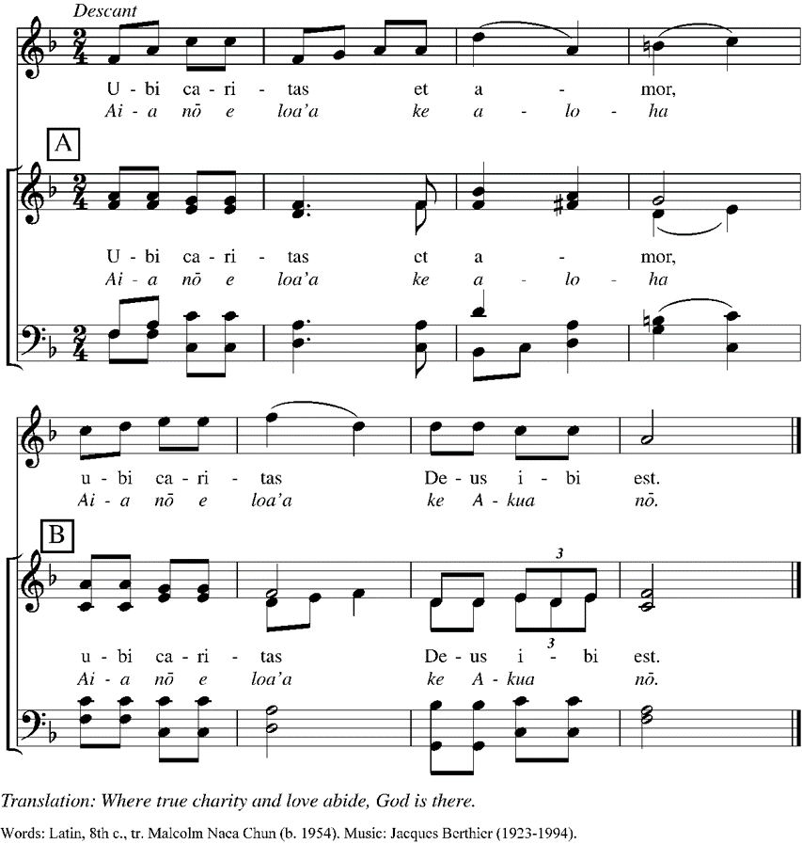

POSTCOMMUNION PRAYER

**Almighty and everliving God,**

**we thank you for feeding us with the spiritual food**

**of the most precious Body and Blood**

**of your Son our Savior Jesus Christ;**

**and for assuring us in these holy mysteries**

**that we are living members of the Body of your Son,**

**and heirs of your eternal kingdom.**

**And now, Father, send us out to do the work you have given us to do,**

**to love and serve you as faithful witnesses of Christ our Savior.**

**To him, to you, and to the Holy Spirit**

**be honor and glory, now and for ever. Amen.**

THE BLESSING

FINAL HYMN ***All sing.***

“We are all one in mission” WLP, #778

DISMISSAL

Go in peace to love and serve the Lord. Alleluia, Alleluia!

**Thanks be to God! Alleluia, Alleluia!**

POSTLUDE

Prelude in g minor by Dietrich Buxtehude (1637-1707)

**MUSIC NOTE**

Louis Mundinger, Music Director

Like last week, we again we have two loved anthems from two different centuries. At the offertory is Hans Leo Hassler’s setting of Psalm 96:1-3. The music is forthright, and captivating, and because of that it always reminds me of a brass choir. There is a march at the beginning and end, with a waltz in the middle.

Sing to the Lord a new song; sing to the Lord, all the earth.

Sing to the Lord, and bless his name: announce his salvation from day to day.

At communion the anthem is by Harold Friedell, “Draw us in the spirit’s tether.” As we leave Eastertide, we can look to the final line of each stanza and sum up the Easter experience. We have touched Jesus’s garment; we are knit together in Christ, and we can be confident disciples just by praying, eating, and giving.

|  |  |  |
| --- | --- | --- |
| 1  Draw us in the Spirit’s tether,  For when humbly in Thy name,  Two or three are met together  Thou are in the midst of them;  Touch we now Thy garment’s hem. | 2  As the people used to gather  In the name of Christ to sup,  Then with thanks to God the Father  Break the bread and bless the cup,  So knit Thou our friendship up. | 3  All our meals and all our living  Make as sacraments of Thee,  That by caring, helping, giving  We may true disciples be.  We will serve Thee faithfully. |

At the prelude, soprano Laura Thomas will sing another cherished piece of music from Handel’s Messiah. This solo, “I know that my Redeemer liveth” opens the third part of Handel’s oratorio. The words are taken from the Bible, Job 19:25-26, and the service for the Burial of the Dead. Laura sings this piece with a confidence that draws the listener to a new understanding of very old words.

I know that my redeemer liveth and he shall stand at the latter day, upon the earth.

And though worms destroy this body, yet in my flesh shall I see God

For now, is Christ risen from the,dead, the first fruits of them that sleep.

*****

LEADERS OF WORSHIP

*Presider* – The Rev. Jennifer McCracken

*Preacher* – Sean Giffin

*Sub-Deacon –* Anne Moore

*Music Director* – Louise Mundinger

*Schola* – Liz Ayres-Kerr, Leo Balkovetz, Alexandra Henderson,

John Meurling, Nicholas Ochoa, Laura Thomas

*Altar Guild* – Rhea Ranno

*Readers* – Jeffrey Seamans & Rhea Ranno

*Intercessor* – The Very Rev. Amy McCreath

*Bread Baker* – Laura Thomas

*Greeters ­–* Bob Acedo, Claire Cocci, & Jan Rowe

*Livestream Minister* – Sean Griffin

SUNDAY COUNCIL

*Deanery Rep. & Justice Ministries* – Rhea Ranno

*Chapter Representative* – Michael Baenen

*Worship and Formation Co-Chairs* – Jeffrey Seamans and Laura Thomas

*Retreat Planning* – Jan Rowe and Anne Moore

*All music printed by permission in accordance with ONE LICENSE, License #A-707998.*

### *Permission to podcast / stream the music in this service obtained from ONE LICENSE, License #A-707998. All rights reserved.*

*****